|  |  |  |  |
| --- | --- | --- | --- |
| 4 | | 23,008.428571428572 | |
| NUMERO DE FRONTERAS | | ENERGIA AGREGADA | |
|  | | | |
| NO | | 0 | |
| CONTRATO | | VENCIMIENTO CONTRATO | |
|  | | | |
| 114,957,332 | 133 | | 4,256,937 |
| INGRESO 2019 | DÍAS CERTIFICADOS 2019 | | ENERGIA RESPALDADA 2019 |
|  | | | |
| 92,641,547 | 157 | | 3,312,608 |
| INGRESO 2020 | DÍAS CERTIFICADOS 2020 | | ENERGIA RESPALDADA 2020 |
|  | | | |
| 50,693,097 | 119 | | 2,214,533 |
| INGRESO 2021 | DÍAS CERTIFICADOS 2021 | | ENERGIA RESPALDADA 2021 |

|  |
| --- |
| **UNIVERSIDAD DE LOS ANDES**  USUARIO |

|  |
| --- |
| **Mateo Porras**  Ejecutivo de cuenta |

|  |
| --- |
| **Nestor Vera / 0 / nvera@uniandes.edu.co**  Primera fecha: PUNTO FOCAL |

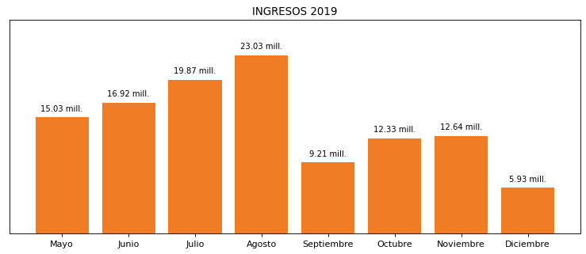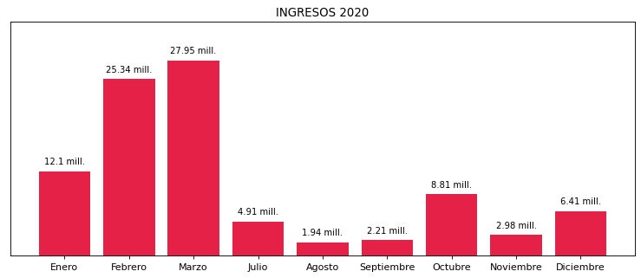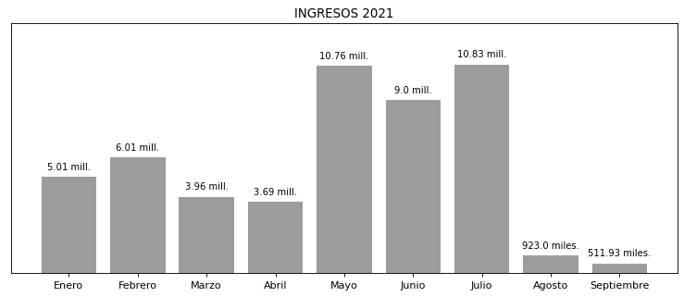

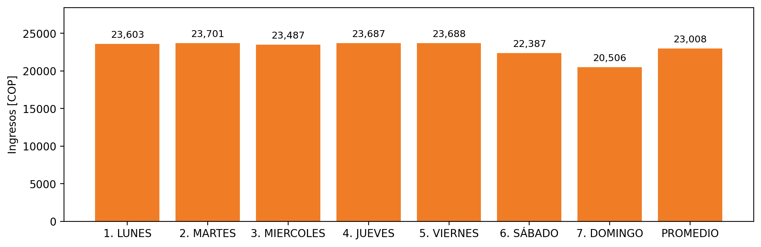

|  |  |  |  |  |  |  |  |  |  |
| --- | --- | --- | --- | --- | --- | --- | --- | --- | --- |
| **FRONTERA COMERCIAL** | **TIPO DDV** | **COD SIC** | **PREDIO** | **PROMEDIO** | **MARGEN** | **ÚLTIMA DESCONEXION** | **DÍAS CERTIFICADOS** | **ACTUALIZACION** | **PROXIMA PRUEBA DDV** |
| UNIVERSIDAD DE LOS ANDES EDIFICIO MARIO LASERNA | Frt32661 | Frt08194 | Prd01269 | 12,323 | 3,43 | 2021-02-09 | 89.0 | 2021-11-25 | 2021-11-30 |
| UNIVERSIDAD DE LOS ANDES (BLOQUE O) | Frt32659 | Frt02152 | Prd01267 | 12,323 | 6,72 | 2021-02-09 | 89.0 | 2021-11-25 | 2021-11-30 |
| UNIVERSIDAD DE LOS ANDES | Frt36402 | Frt02115 | Prd01578 | 12,323 | 7,37 | 2021-02-09 | 90.0 | 2022-02-10 | 2021-11-30 |
| UNIVERSIDAD DE LOS ANDES ( EDIFICIO FRANCO) | Frt32656 | Frt02151 | Prd01264 | 12,323 | 4,66 | 2021-02-09 | 70.0 | 2022-03-02 | 2021-11-30 |